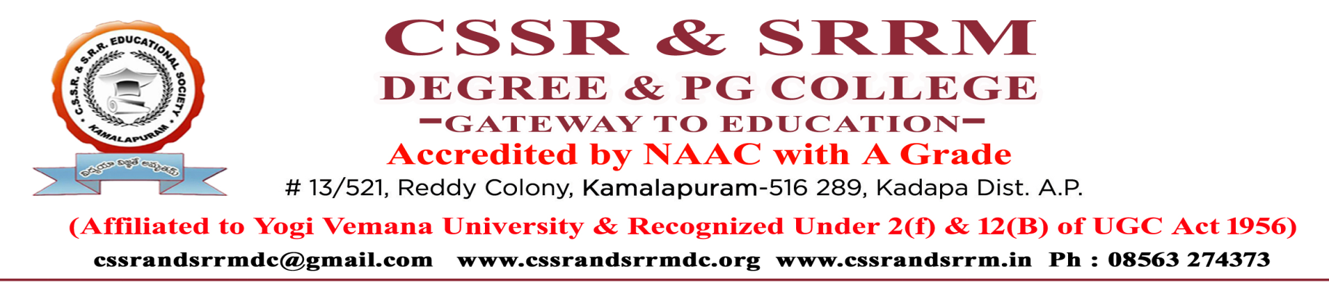
A BRIEF REPORT
Library Visit
Kadapa government public library

Report:
At the request of the first-year students, all the students, and the teaching faculty visited the library of , Kadapa government public library

Kadapa on 15-11-2025 under the supervision of college librarians. The public library secretary and librarian explained the list of volumes and books available in the two libraries, and he introduced the rare collection of books available in the library related to comic books, interior home design, competitive books, painting, photography, story books, autobiography's, encyclopedia, and the govt library. It also provided the knowledge of the books to use in daily life. He also said these are the special and costliest books not available in any other public libraries, other colleges. He said that by imparting knowledge with these books the students also gain knowledge and practically prepare some of the statutes, and some photographs prepared by the students of the college.
At last, all the students and faculty are happy and satisfied on visiting this library and seeing this special kind of books

Pics:

